TWO SPECIAL OFFERS WHILST STOCKS LAST!

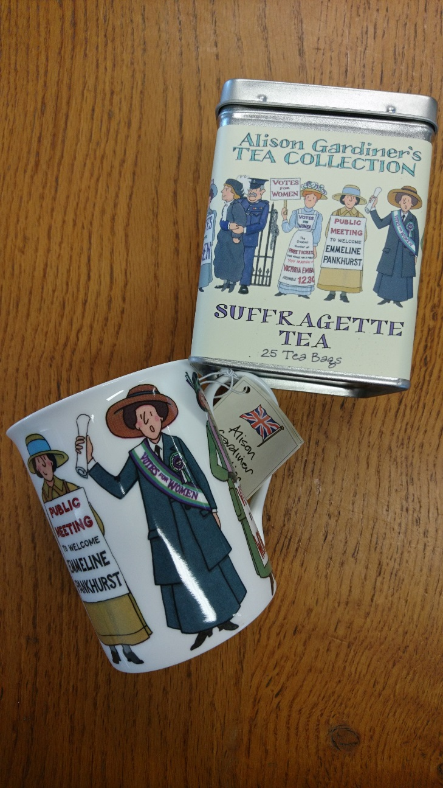
Look no further for the ideal Christmas present for that person who is tricky to buy for!

Suffragette Mug +
Suffragette Tea Caddy
£12.50

Centenary Mug +
Centenary Tea Towel
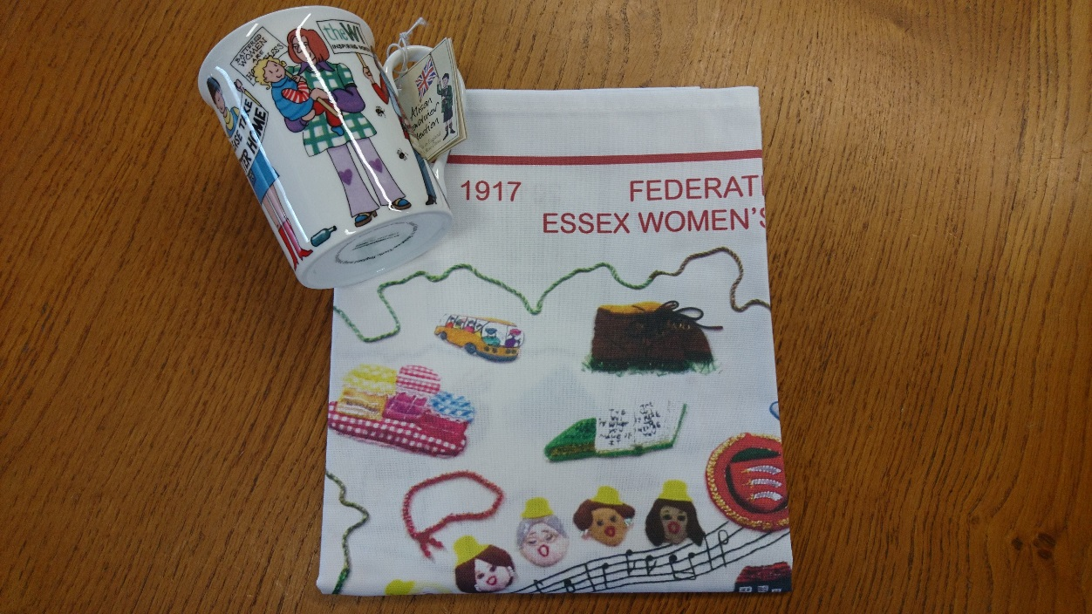
£11.50

